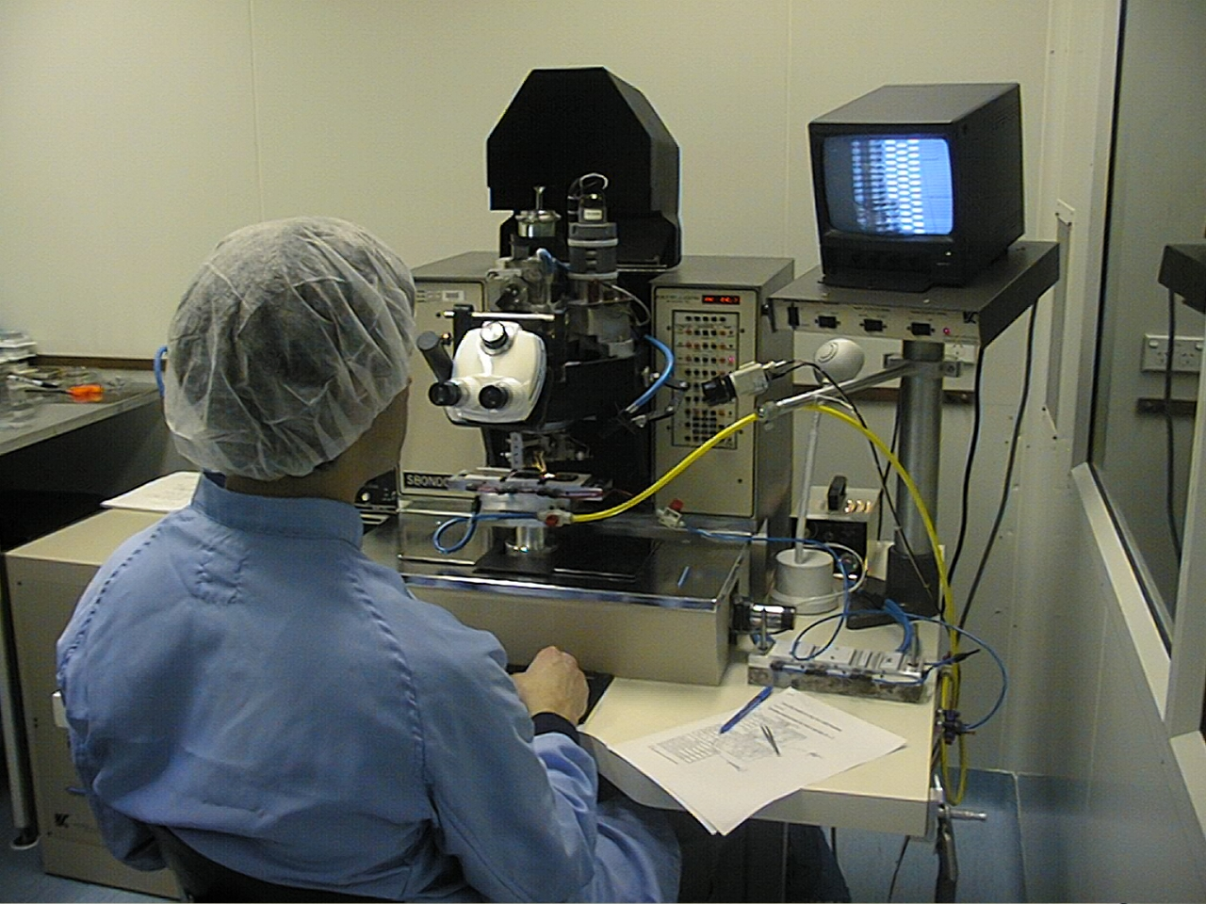

Wire bonding for SCT modules for the ATLAS detector. The wire bonding robot is located in the clean room of the Melbourne laboratory.

