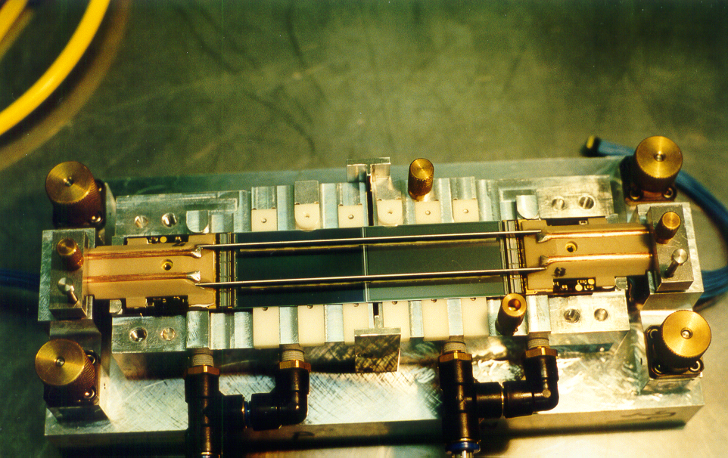

A ladder for the Belle detectors silicon vertex detector. The ladder has just been made and is still in its construction jig.

